Ford Motor Company

**How-to Manual**

Connectivity Team

Dearborn, MI

April 2020

Change Log

|  |  |  |
| --- | --- | --- |
| Date | By | Changes |
| 1/29/2016 | Amit Mohanty | Added 1) how to host a guest in RIC building, 2) how to add One Ford card to your mobile phone |
| 2/1/2016 | Tom Montgomery | Added how to get on Research Lab seminar distribution list. |
| 2/23/2016 | Smruti Panigrahi | Added   1. GDI&A Bulk Mail Subscription to receive GDI&A All Hands Meeting and Knowledge Share Meeting notice (Section 9.9) 2. FORD WHQ Access (Section 9.10) |
| 5/10/2016 | Richard Gordon | Added 3.2 Software Installation topic Share Drive W: |
| 5/20/2016 | Prabhu | Added Printing Bad document instructions |
| 5/20/2016 | Prabhu | Added copyright notice information |
| 6/6/2016 | Tom Montgomery | Added GDIA and Smart Mobility Analytics SharePoint links. |
| 7/5/2016-10/11/2016 | Sheida Malekpour | Set up printer, format, installing MATLAB, putty, reordering the sections (installing the printer), MyLearning@Ford, corporate credit care, pre-trip Approval, Printer setup link was not working, removed it!, RIC safety training edited (it was not a proper copy and paste), Research Library, Getting access to data, and share drive W |
| 9/30/2016 | Connie Panzica | Printer and DORF System for Contractor Worker |
| 08/27/2018-  10/18/2018 | Mumtaz Vauhkonen | Updating Multiple sections with new links and process to get request access. |
| 01/31/2020 | Jarryd Calhoun | Added section on FERA (10.19), updated section 1.4, 1.4.2, 1.4.5, 7, & 10.6 and crossed out sections that seem no longer relevant – sections 5,6, part of 7, 8, 10.12-10.14, and 11. |
| 04/02/2020 | Hessam Olya | Added IT help desk phone number (1.3 - 6)  Updated bashrc setup (1.4.2)  Added access to Jupyter on edge node (1.4.2)  Added Spark Shell (1.4.2)  Added Install and set up MIT Kerberos (1.4.5)  Updated Putty instruction (1.4.6)  Added Getting Access to Slack (1.4.7)  Added Map Drive Y (1.5.1)  Updated Map Drive S (1.5.2)  Added Data and Access (2)  Added Data Sources and Descriptions (2.1)  Added Accessing Data Through SCA-V (2.2)  Updated GDI&A Analytics SharePoint (7.1)  Added GDI&A SharePoint (7.1.1)  Added Mobility Portal (7.1.2)  Added Onboarding Wiki (7.2)  Updated Adding photo to outlook (7.6)  Added working remotely section (7.15)  Added Tech Lounge information (7.16)  Added Webex meeting instructions (7.17)  Added Badging Office info (7.18) |
| 04/30/2020 | Ruijun Wang | Updated request center link for Matlab (1.4.1)  Updated request for Anaconda Edge Node Version ( 1.4.2 (**b**))  Added configuration instructions for PuTTy and access method to HPCHDP2E (1.4.6)  Updated links for on-board wiki (7.2)  Added Ford speak link for abbreviations (7.3)  Added WebEx Camera driver installation (7.17)  Added Slack User Request form in Appendix (8.1)  Added Getting started with Spark Training(7.6) |

Contents

1 Computer and Software 1

1.1 Laptop/Desktop Request 1

1.2 Set up printer 1

1.3 Elevated privilege to install/run software 1

1.4 Software and Access 2

1.4.1 Matlab 3

1.4.2 iPython (Anaconda) 3

**a)****Local Installation** 3

**b)****Anaconda Edge Node Version** 3

1.4.3 R-Project 5

1.4.4 HPC and Hadoop Access 5

1.4.5 Install and set up MIT Kerberos 7

1.4.6 Putty 7

1.4.7 Getting Access to Slack 11

1.4.8 Getting Access to GitHub 11

1.5 Drives 11

1.5.1 Map Drive Y 11

1.5.2 Map Drive S 12

1.5.3 Shared Drive W 13

2 Data and Access 13

2.1 Data Sources and Descriptions 13

2.2 Accessing Data Through SCA-V 14

3 Learning Opportunities 14

4 Corporate Training 14

5 Travel Approval Website 14

6 Ford Global Technologies (FGTL) Website 14

7 Other Useful Links and Information 15

7.1 GDIA Analytics SharePoint 15

7.1.1 GDI&A SharePoint 15

7.1.2 GDI&A Mobility portal 15

7.2 Onboarding Wiki 15

7.3 Ford SPEAK 15

7.4 Ford Dearborn building map 15

7.5 Introduction to Ford Smart Mobility program (YouTube) 15

7.6 Introduction to Getting Started with Spark Training 15

7.7 How to reset your Fordna1/Outlook password 15

7.8 Adding Photo to Outlook 16

7.9 Corporate directory (CDS) 16

7.10 Update your CDS record 16

7.11 GDI&A BulkMail Subscription Request 16

7.12 Access to Ford Motor Company World Headquarters (WHQ) 17

7.13 Printing a Bad Document 17

7.14 Code should be marked as Ford copyright 17

7.15 Research Library 17

7.16 Ford Employee Recreation Association (FERA) 17

7.17 Working remotely 17

7.18 Tech Lounge 18

7.19 WebEx Meeting 18

7.20 Badging Office 18

8 Appendix 18

8.1 Slack User Request from 18

# Computer and Software

## Laptop/Desktop Request

The laptop/desktop request can be made by following the instructions:

Update: Aug 22nd 2018: For Ordering Engineering mobile work station

1. Go to <http://www.request.ford.com/>.
2. Select PC/Laptop requests
3. Choose the option of Replace PC or Incremental PC etc.
4. Follow through the instructions on the form.

If enhanced GPU is needed for your work role, please get approval from supervisor.

When you have a new employee starting at Ford Motor Company, you need to contact Ford Land at least two weeks prior to their arrival (the IT Asset Services team's internal SLA is 5-6 days from the date we receive the request from Ford Land).

## Set up printer

Updated method as of Aug 22nd 2018 for Wagner Place East:

1. Choose print command and the option of PullPrint.
2. Go to the nearest printer located to you and scan your badge or enter your login credentials on the printer
3. Choose the menu to retrieve and print the documents.
4. Sign off from the printer /or it automatically sign’s off after a short duration.

## Elevated privilege to install/run software

Updated: Aug 24nd 2018

From a Chrome browser window, navigate to <https://it1.spt.ford.com/sites/EP/ElevatedPrivilegesExceptionRequest/Forms/My%2520Submission.aspx>

1. Click on the + New icon to start a new request
2. Click through the boxes to open the Word template document
3. Important information to be provided:
   1. Names & CDSIDs
   2. Reasons in the “Install Software” and “Change System Configuration” areas.  Provide suitable justification for requesting administrative privileges.  For example, *“Installation, update and testing of advanced software and application development in GDIA.”*
   3. Your computer host name
4. In the request form, enter your personal data such as: CDSID, Role, Reason for Request – New Request, Manager (as shown in Figure 1.)
5. After providing all the information, click on Submit.  This goes to your supervisor and the I/T manager for approval. Typically, you should get the approval within 3-4 days.
6. After your supervisor approves, to obtain Elevated Privileges implemented it is IMPORTANT to call your IT Help Desk & have a Request Ticket opened to have them implemented. The Help Desk can implement the Elevated Privileges while you are on the phone. You can call the IT Help desk at ext. 74957 [if you have a desk phone], if not call 313-317-4957 and request the IT representative push your admin rights to your laptop.

Figure 1:Elevated privilege to install/run software

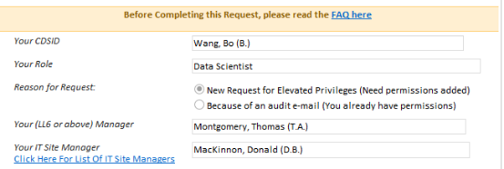

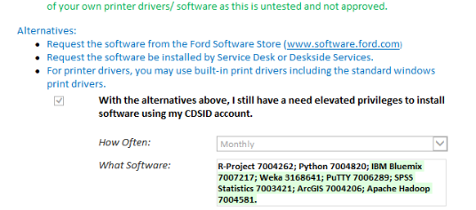

Figure 2: Elevated privilege to install/run software

## Software and Access

You can install common software using either of the first two options.

**Option 1:** Use the Ford Software Center windows app (should be pre-installed on your laptop).

**Option 2:** You can install many common software (e.g. chrome) on this website: <https://www.eassets.ford.com/eassetsWeb/sms/admin/fordselfservicetool/listofAppsAction.do>

If you want to install more specialized software, you need to first ask for elevated privilege to install/run software (see section 1.3)

**Option 3:** Most software can be installed once elevated privileges are obtained. Check with IT to make sure that a certain package can be installed.

### HPC and Hadoop Access

1. The HPC Environment provides access to CAE applications running on a large compute cluster. Batch job submission to the work queue and monitoring of job status are provided. Files to be processed must first be copied to the local cluster scratch storage (this shared drive can be mapped to the local PC “File Explorer” in section **1.5.2**). In order to request access to an HPC account, please follow this link: <http://www.hpc.ford.com/help/>
   1. Submit request ticket for access. Make sure to select “prod” environment option

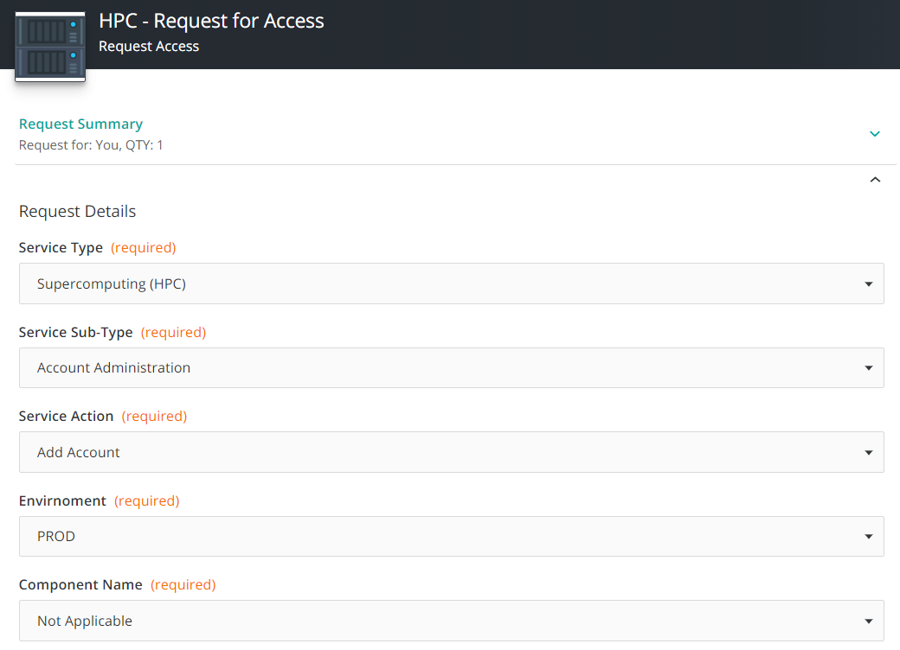

* 1. After receiving confirmation that HPC account is created, reset password at [this location](https://www.hpc.ford.com/passwd/).
  2. This password needs to be manually updated because it doesn’t sync with corporate password.

1. Ford uses Hortonworks Data Platform (HDP), an enterprise version of the opensource Apache Hadoop distribution. Submit a request center ticket (<http://www.hpc.ford.com/help/ticket.html>) requesting Hadoop access and specify access to different environments/clusters depending on need. Whenever a new Hadoop account is created, the users will get only access to the Proof of Concept (POC) Environment. For details about the environments/clusters, please refer to section

**1.4.4**

1. Docker access if needed: Request access to Docker, mlsc group and follow the instructions below.
   1. <http://wiki.ford.com/display/NML/Step+by+Step+Guide+to+Running+Jobs+on+HPC>
   2. <http://wiki.ford.com/display/NML/Getting+Started+With+Docker+on+the+Cluster>
2. Request access to needed database storage

The Discovery Zone is a storage space in Hadoop that allows you to share data tables with others in the organization. It is different from your personal storage space in Hadoop – which you acquire by obtaining a Hadoop account – wherein the data tables are only visible to you.

To obtain access to the Discovery Zone, follow the procedure below: (please also check [this site](https://wiki.ford.com/display/GDG/How+do+I+request+access+to+the+Discovery+Zone) for the up-to-date procedures)

* 1. [https://www.itconnect.ford.com/ux/myitapp/#/catalog/home](https://www.itconnect.ford.com/ux/myitapp/" \l "/catalog/home)
  2. Search for ‘Database – Request for Access’
  3. ‘Request Now’
     1. Mainframe related request?
        1. No
     2. Service Type
        1. Manage Role or Access to Objects
     3. Region
        1. Global
     4. Technology
        1. Hadoop
     5. Application Lookup
        1. 23024-GDIA Discovery Zone (DZ)
     6. Environment
        1. Prod
     7. Server Name
        1. Leave Blank
     8. Database/Schema
        1. Leave Blank
     9. Request Description
        1. Please add <insert CDSID> to GDIADZ. I report to <insert manager’s CDSID>. Access is required for <insert business justification/purpose of use>.

1. Follow Hadoop Set-up Guide

### 

### iPython (Anaconda)

1. **Local Installation**

To install locally you can download the iPython Anaconda from this [website](https://conda.io/docs/user-guide/install/download.html).

1. **Anaconda Edge Node Version**

The install process for Anaconda on the edge node is handled separately. Once an HPC account is created, request has to be placed for anaconda install on HPC. To do so, complete the attestation found on <https://www.itconnect.ford.com/dwp/app/#/itemprofile/1406> and choose “Anaconda” as the product in your request. For the latest information about choosing Anaconda versions on the cluster, visit the Anaconda page on the [Discovery Zone wiki page](http://wiki.ford.com/pages/viewpage.action?spaceKey=DZ&title=Anaconda+Python).

Update June 3, 2020

Once approval notice is received, continue to set up Anaconda on HPC (Hadoop Edge Node) using the instructions at our [Wiki page](http://wiki.ford.com/display/DZ/Anaconda+Python) entitled **“Instructions_for_ HPC_miniconda3”**. The steps i-iii below are for minconda2 installations and serve as a reference. If you finish with **“Instructions_for_ HPC_miniconda3”** successfully, please move on to section **1.4.4**.

1. **Configuring paths to use Pyspark with edge node version of Anaconda**

* Follow instructions on this page: <http://wiki.ford.com/pages/viewpage.action?spaceKey=NML&title=Setup+pyspark>
* Modify your .bashrc file as follows:
  1. Using PuTTY or another SSH program, open your bashrc file by typing into the terminal: vi .bashrc
  2. Press “E” to edit.
  3. Press “I” to insert.
  4. Paste in the following (replace cdsid with your own):

|  |
| --- |
| export PATH=/s/anaconda/users/cdsid/miniconda2/bin:$PATH  export PYSPARK_DRIVER_PYTHON=/s/anaconda/users/cdsid/miniconda2/envs/Py36Kernel/bin/jupyter  export PYSPARK_DRIVER_PYTHON_OPTS="notebook --NotebookApp.open_browser=False --NotebookApp.ip='*'"  export PYSPARK_PYTHON=/s/anaconda/users/cdsid/miniconda2/envs/Py36Kernel/bin/python3.6  export SPARK_HOME=/usr/hdp/current/spark2-client  export SPARK_MAJOR_VERSION=2 |

* 1. Press Esc.
  2. Type “:wq!” to save the changes.

1. **Access to Jupyter on edge node**

In order to access Jupyter notebook on edge you need approved HPC production server access. Once your access is approved, follow the instruction below to open Jupyter notebook on edge.

1. Open putty. You should see the following in the command line that indicates that you are in the Hadoop environment.

In case you get a shell prompt, but the production server acknowledges login and takes no input, you need to submit a ticket, or contact [mabd@ford.com](mailto:mabd@ford.com).

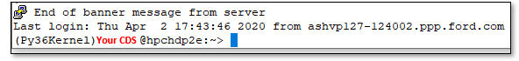

*Figure 3: Putty shell prompt*

1. In the command line type in “Jupyter-notebook”
2. After few seconds you see a port number as shown below.

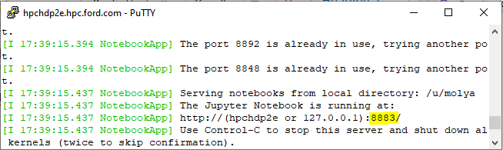

*Figure 4: Jupyter notebook port number*

1. Copy the port number and replace “[port number]” in the following link with the generated code.

[http://hpchdp2e.hpc.ford.com:[port number]/](http://hpchdp2e.hpc.ford.com:[port%20number]/)

1. Open your internet browser and copy the link.
2. Enter your Jupyter password.
3. Press enter and you will be in Jupyter home page.
4. **Spark Shell**

Spark Shell is an interactive shell through which we can access Spark's API. After logging into Jupyter, make sure that you can run the following spark shell command successfully since you will need this in future for your project developments.

**Note**: this code can change frequently so in case you get any error, you can always ask for the updated one from the team and update this section.

|  |
| --- |
| ###################### Setup the Environment Variables ###################  import os  import re  import sys  spark_home = os.environ.get('SPARK_HOME', None)  #print(spark_home)  #spark_home = r'/usr/hdp/current/spark2-client'  spark_home = os.environ.get('SPARK_HOME', None)  if not spark_home:  raise ValueError('SPARK_HOME environment variable is not set')  if not os.path.isdir(spark_home):  raise ValueError('SPARK_HOME environment variable is not a directory')  if not os.path.isdir(os.path.join(spark_home, 'python')):  raise ValueError('SPARK_HOME directory does not contain python')  sys.path.insert(0, os.path.join(spark_home, 'python'))  pylib_list = (item for item in os.listdir(os.path.join(spark_home, 'python/lib/'))  if re.match(r'py4j-\d+(\.\d+)+-src\.zip\Z', item)  )  try:  py4j_file = max(pylib_list)  py4j = os.path.join(spark_home, os.path.join('python/lib', py4j_file))  except ValueError:  raise ValueError(  'Could not find py4j'  )  sys.path.insert(0, py4j)  spark_release_file = spark_home + "/RELEASE"  if os.path.exists(spark_release_file) and "Spark" in open(spark_release_file).read():  pyspark_submit_args = os.environ.get("PYSPARK_SUBMIT_ARGS", " --master yarn-client \  --num-executors 16 --executor-memory 32g --executor-cores 4 --driver-memory 40g --conf spark.dynamicAllocation.maxExecutors=2000 --jars /usr/hdp/current/hive_warehouse_connector/hive-warehouse-connector-assembly-1.0.0.3.1.4.39-6.jar --py-files /usr/hdp/current/hive_warehouse_connector/pyspark_hwc-1.0.0.3.1.4.39-6.zip --conf spark.hadoop.metastore.catalog.default=hive --conf spark.driver.maxResultSize=3g"  )  if not "pyspark-shell" in pyspark_submit_args: pyspark_submit_args += " pyspark-shell"  os.environ["PYSPARK_SUBMIT_ARGS"] = pyspark_submit_args  with open(os.path.join(spark_home, 'python/pyspark/shell.py')) as f:  code = compile(f.read(), os.path.join(spark_home, 'python/pyspark/shell.py'), 'exec')  exec(code) |

### 

### 

### Putty

You may need to have putty, launch the software center app (pre-installed on pc) and search for “putty”. Installation instructions can be found at: <https://www.hpc.ford.com/help/putty.html>

You may need to have access to:

* + HPC: [Your CDSID]@hpclogin.hpc.ford.com
  + HPCHADOOP: [Your CDSID]@hadoop.hpc.ford.com
  + HPCHD1E: [Your CDSID]@hpchd1e.hpc.ford.com
  + HPCHDD2E: [Your CDSID]@hpchdd2e.hpc.ford.com
  + HPCHDP2E: [Your CDSID]@hpchdp2e.hpc.ford.com

When you have the access to HPC edge node at hpclogin.hpc.ford.com, it DOES NOT mean that you can access HPCHDP2E.

In order to use HPCHDP2E you need to request access for “Environment - Standard PROD” in SCAVehicle domain via [Access Management Website](https://www.accessmgmt.ford.com/CspsWeb/cspsHomeBegin.do).

If the access is denied, that probably because you are not added to the GDIADZ zone. Go to [this link](http://wiki.ford.com/pages/viewpage.action?spaceKey=GDG&title=Discovery+Zone+Temporary+Request+Process) and follow the instruction to request for the access to GDIADZ. After your access request has been approved, you are able to login into the HPCHDP2E.

In addition, S drive is needed to put your code there to be able to run them in HPC (see section **1.5.2**).

Next, we need to configure putty to use the Kerberos ticket we set up earlier:

1. Select Connection>SSH>Auth>GSSAPI
2. Check the box by ‘Attempt GSSAPI authentication (SSH-2 only)’
3. Check the box by ‘Allow GSSAPI credential delegation’
4. 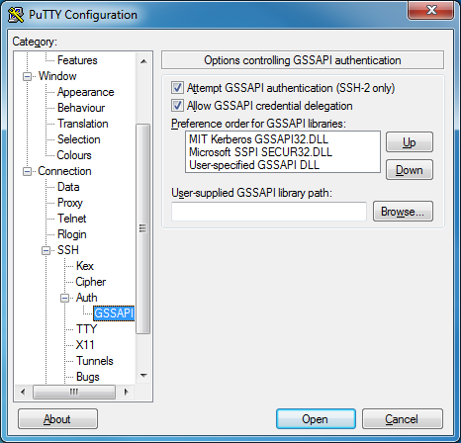Make sure that ‘MIT Kerberos GSSAPI64.DLL’ is at the top of the preference list.
5. DO NOT CLICK OPEN. Instead, select ‘Session’ in the ‘Category:’ field on the left side.
6. 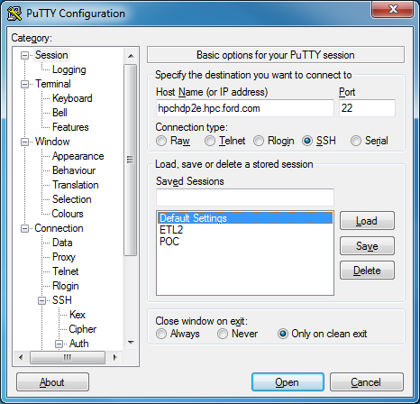Enter something in the ‘Saved Sessions’ text box (for example HPC Prod) and click Save. This way, you will not have to enter this information every time.
7. Click “Open” to connect to the edge node.

See [Putty-Help](http://www.hpc.ford.com/help/putty.html) for more information.

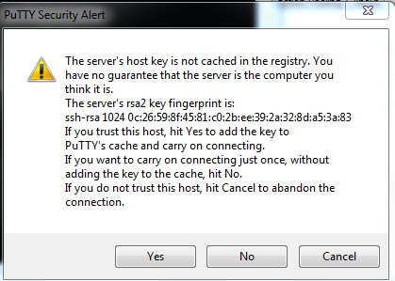Now you should be able to log in using your Kerberos credentials and type commands. When you open a session with a server, a security alert similar to the one below may appear. Click *Yes.*

### 

### Getting Access to GitHub

1. Navigate to [Access Management Website](https://www.accessmgmt.ford.com/CspsWeb/cspsHomeBegin.do) (APS).
2. Click the green Go button next to your name.
3. On the next screen, type “GitHub” into the blank field (next to the "All Application Domains" dropdown to the right of the search box) and click Search button.
4. This should show the GitHub application in the “Applications” section towards the bottom of the screen, click the word GitHub to expand the list of roles.
5. Scroll down and find the “GitHubFordUser” role and click on Request Access (Green button on the right side of the screen).
6. Enter a “Note to Approvers” if applicable (i.e. the skill team you are requesting access for) and click the “Submit Request” (Green button).
7. Once your access is approved you can use your Ford credentials to login to the production instance at <https://github.ford.com>

## Drives

Please contact your supervisor to get access to the Mobility Solutions SharePoint site.

### Map Drive Y

Users can request Y-Drive following [this link](https://www.fam.ford.com/apps/YDRIVE/). You can have your personal shared drive and your network drive mapped to “File Explorer” in local PC without having to look for it or type its network address each time.

1. Open **File Explorer**from the taskbar or the **Start** menu, or press the **Windows logo key**  +**E.**

2. Select **This PC**from the left pane. Then, on the **Computer** tab, select **Map network drive.**

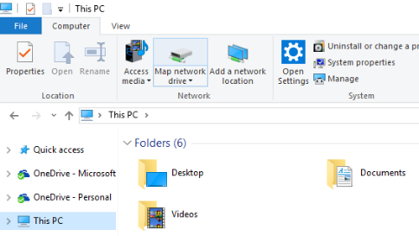

*Figure 9: File explorer and map network drive*

3. In the **Drive** list, select a drive letter. (preferably letter Y)

4. In the **Folder** box, type the path of the folder or computer as below:

* \\FMC9000201.MD2.FORD.COM\[Your CDS]$

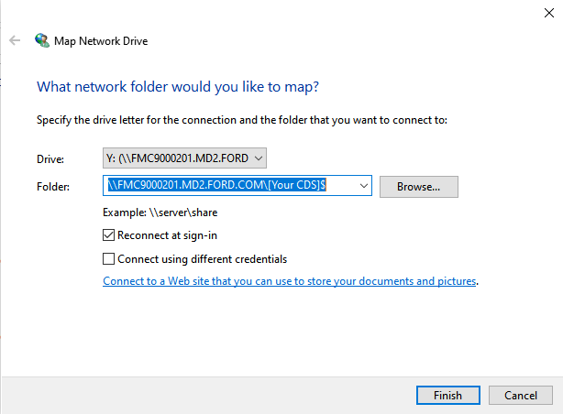

*Figure 10: Map Network Drive Settings*

To connect every time, you log on to your PC, select the **Reconnect at sign-in** check box.

5. Select **Finish.**

### Map Drive S

Follow the instructions under:

<http://www.hpc.ford.com/help/filemanage/samba.html>

Drive S path: \\hpcsmb.hpc.ford.com\scratch

### Shared Drive W

Update on June 3, 2020

Shared Drive W has been migrated to corporate datacenter and is no longer available

Send an e-mail to reshelp@ford.com and ask to have access to the drive shown in Figure 8.

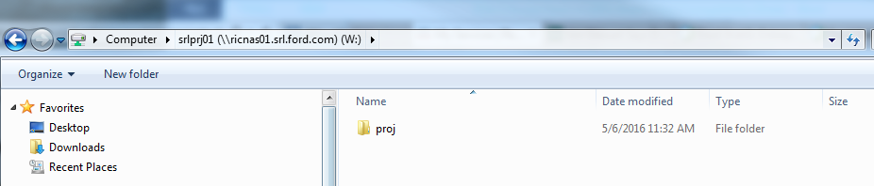

Figure 11: Drive W:

Figure 8 shows how the W: drive address looks like when completed. Provide this address: ricnas01.srl.ford.com\srlproj01 if the IT staff reaches out to you for more information regarding the shared drive.

Note: Share a file with someone on your team through this drive to verify functionality.

Remember that drives S: and W: get cleaned frequently! So, make sure you have a backup from the files and folders you have on these drives.

# Data and Access

## Data Sources and Descriptions

SCA-V is a Hadoop data lake that hosts several mobility data sources. For instance, one of the data sources that we use frequently is TCU4% data that comes from vehicle models. Figure 12 illustrates the landscape of TCU4G data. You can find the description of data sources in the following link.

[Mobility Data Sources and Transformations](https://pd2.spt.ford.com/sites/ConnectedVehicle/Web%20Part%20Pages/Data%20and%20Transforms.aspx)

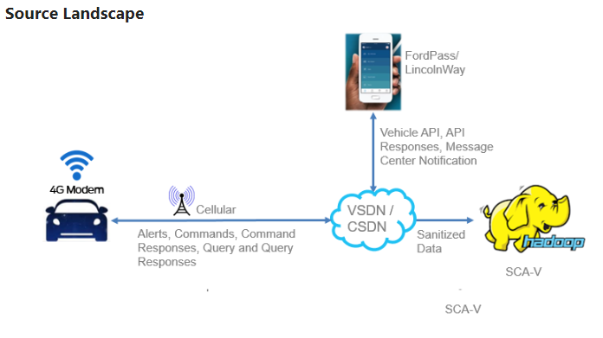

*Figure 12: TCU4G data source landscape*

## Accessing Data Through SCA-V

Put request through the [Access Management Website (APS)](https://www.accessmgmt.ford.com/CspsWeb/cspsHomeBegin.do); follow the instruction under:

1. Go to: <https://pd2.spt.ford.com/sites/ConnectedVehicle/Web%20Part%20Pages/CONNECT%20TO%20MOBILITY.aspx>
2. Click on [APS](https://www.accessmgmt.ford.com/CspsWeb/cspsHomeBegin.do),
3. Click on GO (green button)
4. Type SCAV
5. Click on the SCAV link
6. Choose the table that you need in the populated list. And click the green Request Access” button. Fill the description clearly. Name the project and your supervisor.

# Learning Opportunities

You can find learning opportunities at: [MyLearning@Ford](http://www.integrity.ford.com)

# Corporate Training

You should complete the corporate training within the first year. It is available on this website: [www.integrity.ford.com](http://www.integrity.ford.com).

# Travel Approval Website

All business travel should be approved on this Ford Corporate Travel website. <https://www.ter.ford.com/BackOffice/home.html> You can find the following forms on this website:

* Concur Travel Online
* Pre-Trip Approval Request
* Meeting and Event Registration
* Launch Registration
* Information regarding corporate credit cards

# Ford Global Technologies (FGTL) Website

All the intellectual-related properties (patents and publications, etc.) should be submitted and reviewed on the FGTL website before publishing. FGTL is a wholly-owned subsidiary of Ford Motor Company. As a member of the Office of the General Counsel, we are responsible for managing intellectual property matters for Ford Motor Company and its affiliate companies. FGTL manages patents, trademarks, copyrights, licensing matters, research and development contracts and trade secrets.

You can follow the instruction on this website to submit your approval request: <http://www.fgti.ford.com/client/NewFGTI/index.html>

# Other Useful Links and Information

This section contains other useful information.

## GDIA Analytics SharePoint

### GDI&A SharePoint

You can find latest news and information about GDI&A on [GDI&A SharePoint](https://azureford.sharepoint.com/sites/gdiateam/SitePages/GDIA-Team-Home.aspx).

Click on Smart Mobility to find out more about our team.

### GDI&A Mobility portal

If you would like to explore and gain an understanding of the available Mobility data, [GDI&A mobility portal](https://pd2.spt.ford.com/sites/ConnectedVehicle/Web%20Part%20Pages/Home.aspx) consolidates high level information about many of our data sources and provides detailed access instructions.

## Onboarding Wiki

If you are new to data science you may find the [on-boarding Wiki](http://wiki.ford.com/display/NML/On-Boarding+%7C+New+to+Data+Science) page useful.

Here is the link for [Connecting Jupyter notebook to](http://wiki.ford.com/display/DZ/Connecting+Jupyter+notebook+to+Spark2) Spark2

<http://wiki.ford.com/display/DZ/Connecting+Jupyter+notebook+to+Spark2>

[Hadoop COE Training](http://wiki.ford.com/display/HA/Hadoop+COE+Training)

<http://wiki.ford.com/display/HA/Hadoop+COE+Training>

## Ford SPEAK

for finding abbreviations <http://www.rlis.ford.com/fordspeak/>

## Ford Dearborn building map

Please use the following link to identify the Ford campus map. You should open this link with IE explorer.

<https://hr.spt.ford.com/sites/FordInterfaithNetwork/NDoP/NDoP%20Information/Forms/AllItems.aspx?RootFolder=%2fsites%2fFordInterfaithNetwork%2fNDoP%2fNDoP%20Information%2fBuilding%20Maps&FolderCTID=0x01200073874BF230BB2F4D84B95F2AB51F97D2>

## Introduction to Ford Smart Mobility program (YouTube)

<https://www.youtube.com/playlist?list=PLMv38wXUwPqhULl3Ww38eS6VvcPP0o17U>

## Introduction to Getting Started with Spark Training

<https://github.ford.com/HadoopArchitecture/GettingStartedWithSparkTraining>

## How to reset your Fordna1/Outlook password

1. Open Internet Explorer (if prompted for ID and Password, do not try to log on)
2. Go the Ford default home page [http://www.at.ford.com](http://www.at.ford.com/)
3. Click on the Resources, Tools then Job-Related Tools
4. Click on Reset My Password and follow the instructions to reset password

Note: Your password will expire every 90 days. You will be notified 17 days in advance of expiration, along with the procedure for resetting. If password expiration does occur, or you get locked out, and are unable to answer correctly the (2) security questions, you must contact corporate at x74957 to reset your password for you.

## Adding Photo to Outlook

* + - 1. Go to <https://www.office.com>.
      2. Log into your account with your Ford credentials.
      3. At the top of the page, select your name or profile picture
      4. In the My account pane, select your profile picture.
      5. In the Change your photo dialog, select Upload a new photo.
      6. Choose a photo to upload and select Apply.

Note: Your new photo will appear the next time you sign in to Office 365.

## Corporate directory (CDS)

Location: <https://www.sdcds.ford.com/>. To search: Type in the CDSID, or last name of a person, then the first initial to locate a specific person.

Note: The last 5 numbers of a phone number are to be used when dialing a Ford Cisco IP phone. This does not hold true for the cell phones that are being utilized by many employees.

We have also added you to the **R&A distribution list** so that you will receive email announcements regarding seminars and other building events.  These will come from:  Research Computer Systems Help Desk.  If you aren't getting these announcements, check your Junk E-mail folder.

## Update your CDS record

It is important to make sure your CDS record is up-to-date. You can update your record at <https://www.silas.ford.com/silas/updtcds.cgi?ID=node3>

## GDI&A BulkMail Subscription Request

You can request to be a member of the BulkMail subscription list to receive meeting notices about All Hands Meetings and Knowledge Share Meetings etc. Follow the steps below to subscribe to GDI&A BulkMail:

1. Go to link: <http://bulkmail.ford.com>
2. Login with your CDSID and Password
3. Click on “Search Advertised Subscription Lists” or “List Advertised Lists I'm NOT a member of”
4. For example, search for “ITIO_HPC_HADOOP”
5. Click on “Details”
6. Click on “Subscribe” to subscribe to the “IT Advisories for the HPC Hadoop Environment”  or “Unsubscribe” to be removed

## Access to Ford Motor Company World Headquarters (WHQ)

Certain meetings such as GDI&A All Hands Meeting are conducted in the WHQ building. The members of these teams located in Dearborn, MI are expected to attend the meeting in person as opposed to joining via WebEx.

WHQ Address:

FORD MOTOR COMPANY

World Head Quarters (WHQ)

One American Road

Dearborn, MI 48126

In order to access the WHQ building,

1. Go to the main entrance on the south side of the building with all the flags.
2. Your badge should to work at this entrance by default, but not at other entrances to WHQ.
3. If there is a problem with your badge, there is a guard station there to help.

## Printing a Bad Document

Sometimes, someone prints a bad document.  It prints a whole ream of paper with strange characters at the bottom and seems there is no way to stop it.

If that happens, you can call the IT Help Desk at 7-4957 or go on line to the request center to open a ticket at https://www.itconnect.ford.com/dwp/app/#/catalog, click on the printer/plotter request.  Give the printer name and IT can stop the printing.

## Code should be marked as Ford copyright

Software is protected by copyright and/or trade secret.  All that is necessary to protect by copyright is the notice in the file (no need to file with the government). The top commented line should be something like this:

© 2016 Ford Motor Company

For trade secret, you must apply through the internal FGTL web site (Ford Global Technologies LLC) in the same way that you apply for a patent.  ANY CLEVER IDEA THAT YOU COME UP WITH is potentially worth applying, regardless of whether it is implemented or goes into production.  You get a monetary award if the idea is deemed good, more if they apply for a patent or grant trade secret status, even more if it goes into production use. The US is “first to file” now, so speed is also important.

## Research Library

The Research Library is a resource available to everyone.  They can do professional literature searches, provide access to academic papers (even purchase when necessary), loan both regular and e-books, and so on.  Located at RIC, all employees can access RLIS regardless of whether your card is active for the main part of RIC.

## Ford Employee Recreation Association (FERA)

The Ford Employees Recreation Association is a Michigan non-profit corporation providing programs and services to Ford Motor Company employees, retirees, and other A/Z/D Plan eligible persons in Michigan. <http://www.fera.org/>.

## Working remotely

This website contains information about how you can work remotely via different devices.

<https://azureford.sharepoint.com/sites/workremotely>

Follow the instruction described in [this link](https://azureford.sharepoint.com/sites/workremotely/SitePages/On%20A%20Ford%20Laptop.aspx#video-guides) and watch the video at the bottom of the page to setup your VPN connection.

## Tech Lounge

If you have problems with your device, you can take your machine to Tech lounge. Tech lounge is your place for real-time, hands-on technology help and support.

x.ford.com\findmyTechLounge

[TLNA@ford.com](mailto:TLNA@ford.com)

## WebEx Meeting

​WebEx Meetings is an online tool that allows you to virtually meet with colleagues without leaving your home or office. Here is the [instruction](https://www.digitalworker.ford.com/SitePages/Content.aspx?CID=33) for getting started.

If the camera for WebEx meeting does not work, here is the instruction for setting up camera. <http://wiki.ford.com/pages/viewpage.action?spaceKey=GDA&title=How+to+Activate+the+Webcam+on+your+Laptop>

## Badging Office

You can find information about badging office and its location in the table below.

|  |  |  |
| --- | --- | --- |
| Local Phone | 313-390-4861 | https://www.netbadge.ford.com/image/BadgingLocation.png |
| Ford Internal Phone | 04861 |
| Toll Free Phone | 800-763-1424 |
| Email | [ssystems@ford.com](mailto:ssystems@ford.com) |
| Address | Personnel and Administration Building  Room 154   20801 Oakwood Boulevard Dearborn, MI 48121 |
| Hours of Operation | 7:30 – 12:30  Dearborn Time |

# Appendix

## Slack User Request from

**New Slack User Requests:**

In order to access Slack, you must read and attest to the following, [Slack Usage and Procedure Document](https://it.extspt.ford.com/sites/SlackEnterprise/UserDocs/Documents/Slack%20Usage%20and%20Procedure%20Document.doc) **\*\*Only one Request is required if you need access to multiple Teams\*\***

Slack has only been approved for **US, Canada, Brazil, China, India, Mexico, EU & Australia** users only. If you would like to request Slack Usage for a new country please submit a new request in this list: [New Country Enrollment](https://it.extspt.ford.com/sites/SlackEnterprise/Lists/New%20Country%20Enrollment/AllItems.aspx).

If you have read the Ford Slack Usage & Procedure document and agree that you are an eligible user, send an email to the workspace owner/admin with a copy of this completed request.

To learn more about Slack, visit these public Slack Reference pages: [Slack Tips and Tricks](https://get.slack.help/hc/en-us/categories/200111606) (*** Note:  Some of the options within the Slack Reference pages are not allowed per the Ford Slack Usage & Procedure document)

**Ford CDSID:**

|  |
| --- |
|  |

**Business Case:**

|  |
| --- |
|  |

I authorize Ford to provide my name and email address to Slack to manage my Slack account, including sending informational emails.

I have reviewed the Slack Usage Agreement that is located at the link below and I agree to all rules/responsibilities listed in this document:

[Usage Agreement](https://it.extspt.ford.com/sites/SlackEnterprise/UserDocs/Documents/Slack%20Usage%20and%20Procedure%20Document.doc)

**Employee Type:**

Choose an item.

**Team Name:**

|  |
| --- |
|  |

**Team Owner** (Owner of Slack Team that user wants to join)**:**

|  |
| --- |
|  |